Introduction: The digital system I designed is a computer vision algorithm acceleration on Zedboard. The reason why I choose this topic are trying “hello world” project on computer vision and utilize the hardware parallelism property to perform acceleration of some algorithm.
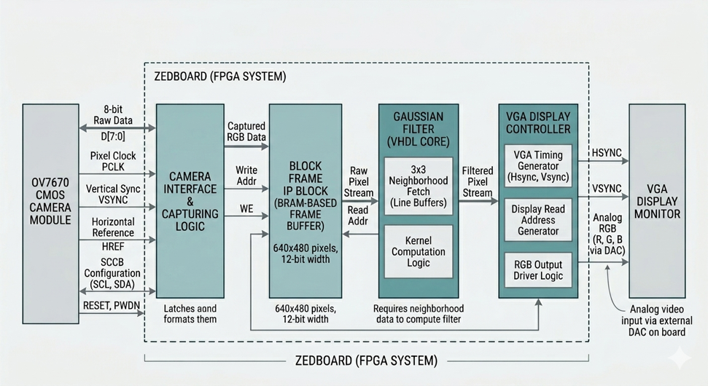
Design:
ov7670 camera module Zedboard capturing Block frame IP block gaussian filter (vhdl) VGA display
ov7670 camera module: responsible to sending pixel data to Zedboard
Zedboard: initialization and configuration of ov7670, capturing the pixel bit flow from ov7670 module, using an Block Memory IP as frame buffer, perform the gaussian filter with acceleration and sending the filtered data to VGA for display
VGA Display: receiving the data from Zedboard and display.
(generate by Gemini on 14/5 6:42 pm)
I think this figure is good enough to show what I say that’s why I put this here

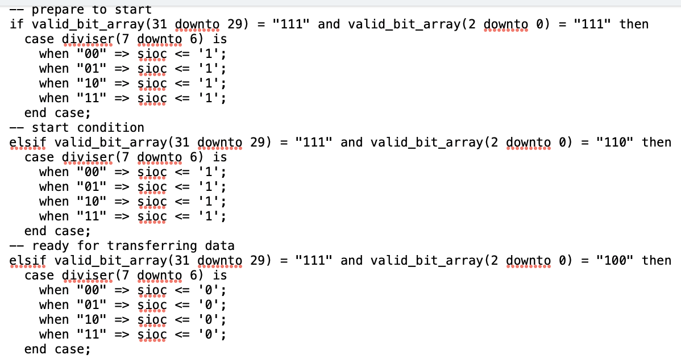
Implementation:
1. Initialization of camera module ov7670
ov7670 is using SCCB protocol which is a I2C type protocol for communication. The protocol is: start condition + id + ack + reg + ack + value + ack + stop condition. Bit numbers are: 3+8+1+8+1+8+1+2 respectively. SCCB_sender.vhd is the vhd file that responsible to perform the protocol. I will say sioc is SCL and siod is SDA in I2C. I use taken and having data as output and input port for Valid-Ready handshake when sending every command line to the ov7670 register. The usage of the diviser is to do clock divisor. For the size of the divisor, it doesn’t matter much, just need to amend the clock Hz. The divisor helps us to simulate the start condition and end condition for communication.
Here is the start condition:

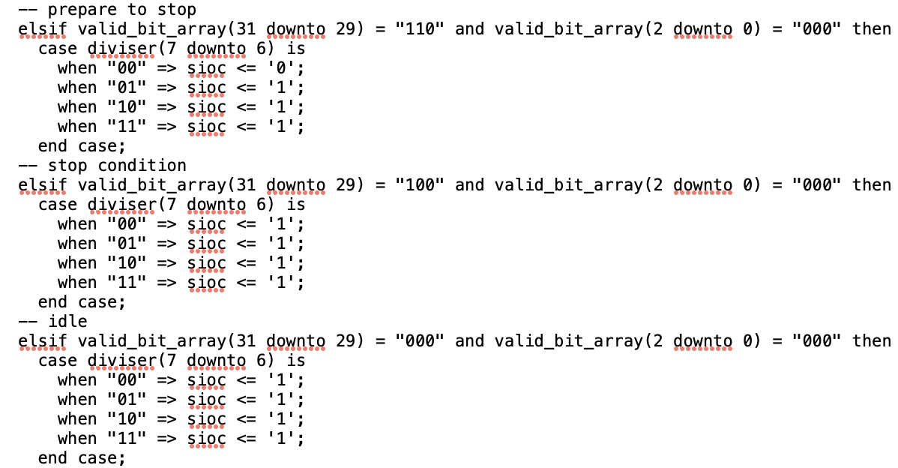
Here is the stop condition:

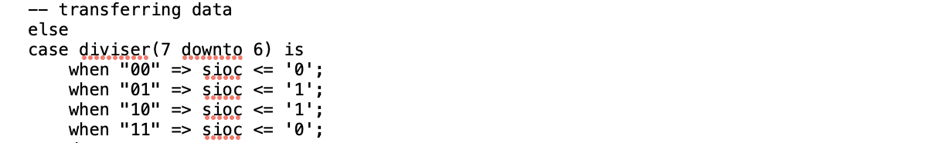
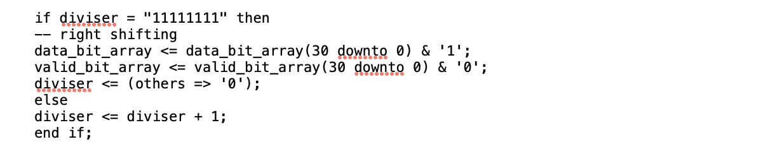
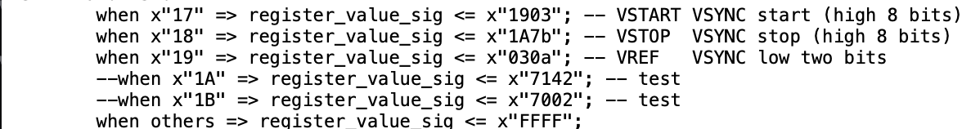
Here is the transferring data condition
I think Mike’s right shift algo for transferring all data is so brilliant, so I follow his method. It bypasses the traditional FSM design.
Also, the reason why I set diviser is "00000001", this gives some time for the ov7670 setting up preventing the command line that required to initialize the ov7670 become invalid because the ov7670 is not yet setting up.
For the ov7670_register.vhd, it let the SCCB sender know what to send to configure the ov7670, most of the line, I am using the setting of Mike’s one. There exists 2 lines “1A” and “1B” are used for debug and testing whether the camera functions properly.

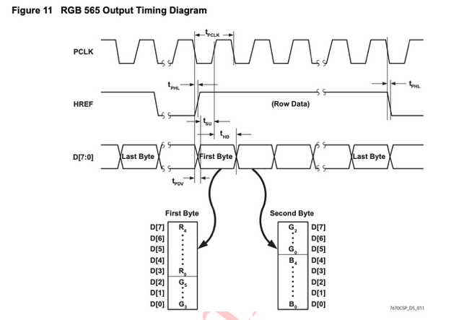
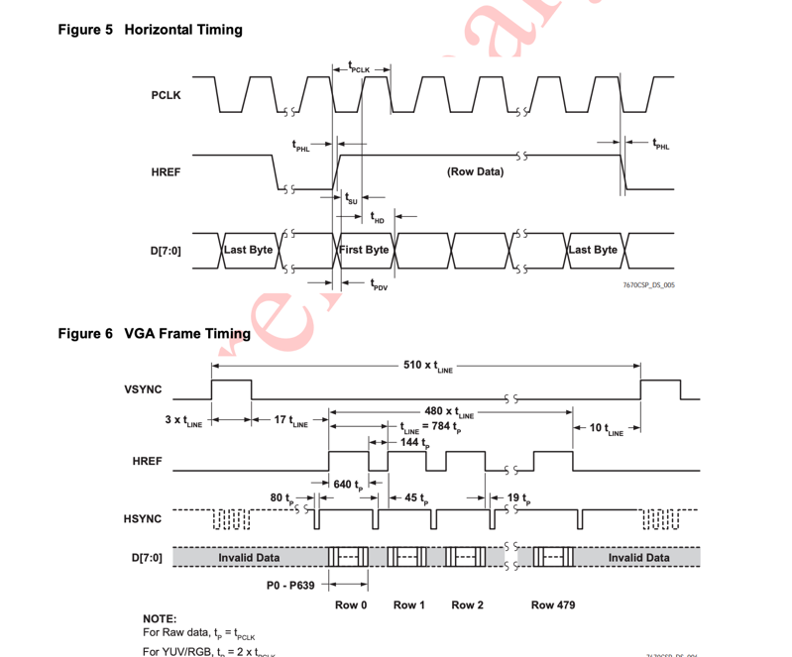
This two file is used as modules for initialization, for ov7670_controller.vhd, it is the top modules for initializing the ov7670. Basically, it combines the two files I mention above, doing port map. For the Device Write ID is x”42”, which can be found on the top of page 11 of data sheet. Reset signal have to be 1 and pwdn must be 0 to make ov7670 work in normal mode and power up, this can be found on datasheet page 4 table 1: pin description, pin number B1 and F2. Since xclk need to configure as 25Mhz, so I write a clock divisor on here, to divide 50Mhz clk. This is the end of the initialization of ov7670.
2. Capturing the data from ov7670 on zedboard
The vhd file used is VGA_capture.vhd
I did not use the Mike’s Method. I choose to use a simpler logic to handle the capturing logic. One pixel required two bytes to transfer according to the datasheet.
I use bytes_flag as a signal that control how data_in store in data_out_signal. When bytes_flag equal 0, store the data_in to the first byte of data_out_signal; When bytes_flag equal 1, store the data_in to the second byte of data_out_signal. Note that I am using a variable instead of signal because if I use signal, in the statement “data_out <= data_out_signal (10 downto 7) & data_out_signal (15 downto 12) & data_out_signal(4 downto 1)” the data_out will use the old data_out_signal(7 downto 0) which is the last pixel second byte. Therefore, I use variable instead of signal, even this is not recommended by Prof. Yang. Though I don’t know why the data is captured as like this, but under my testing, found that it can correctly forming the image while others are strange image.
Also, the logic for VSYNC and HSEF controlling the pixel flow is referring to the datasheet page 7 table 5 and 6.
The general FSM diagram of capturing is shown below.
(generate by Gemini on 15/5 4:33 pm)
3. Block frame
This is the IP in the Vivado. At first, I want to use FIFO instead of Block Memory because Block Memory required huge BRAM which is a extremely limited resources for Zedboard. However, when I use FIFO, I was facing a huge problem that ov7670 is providing 30 fps image while VGA required 60 fps. If I used FIFO, it would lead to one frame image and one frame black which is not my desired result. Therefore, I choose to use Block Memory which can store 1 frame of image and allowed the VGA display to read the frame of image twice to provide image without black image. This part of resources is unable to resolved due to this issue.
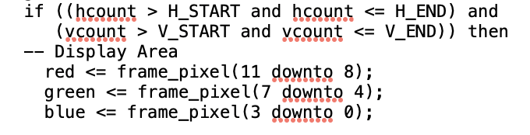
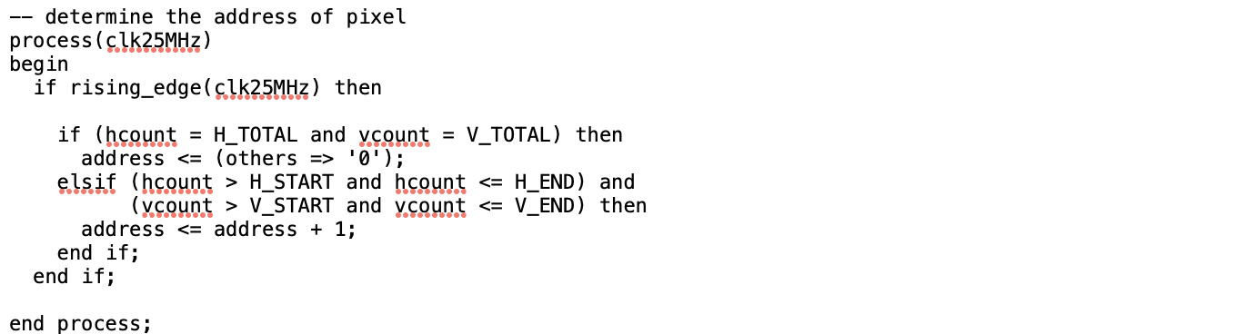
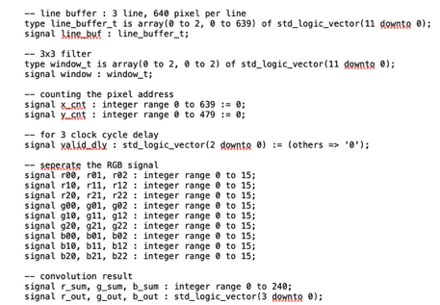
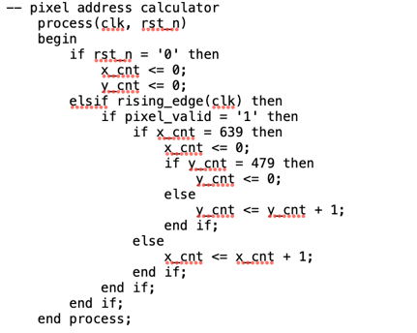
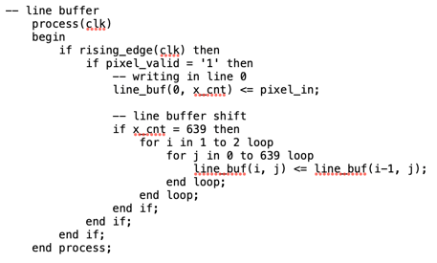
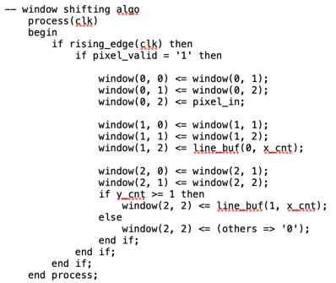
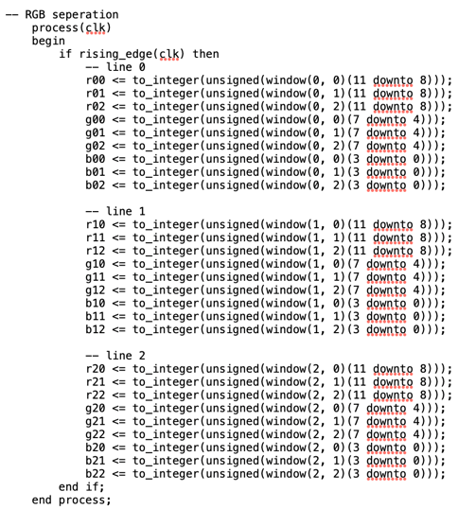
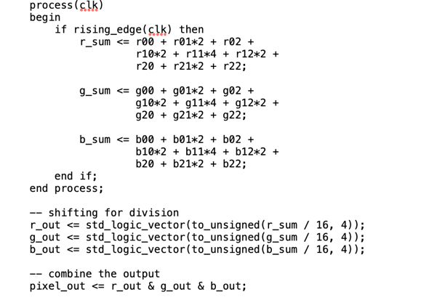
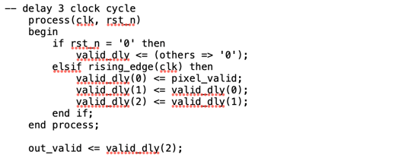
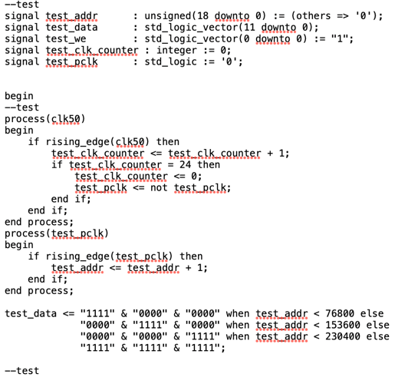
4. VGA Displaying (this is the path for pixel from zedboard to VGA)
Declaration: I am using the template given in the lab which teaches us how to use the VGA.
The only stuff I added are the logic controlling the pixel address and the display area.
I also modify the boundary inside the condition of if statement to fully follow the VGA initialization since the lab version’s generation of hsync and vsync is 1 pixel difference from the requirement. It won’t affect pure VGA display but do affect the image when integrating the ov7670 module.
5. Gaussian filter:
This filter is achieved in gaussian_filter.vhd. There are many parts in this file.
Let’s investigate the signal I declared. I defined a 2D array (0 to 2, 0 to 639) to store three rows of raw image data. Second, a 3x3 2D array as a 3x3 filter, defined as window. I defined a signal valid_dly responsible for 3 clock cycle delay.
Then, the first part is pixel address calculation.
Second is the line buffer. I use three-line buffer in order to store the 3 lines of the pixel data allowing the 3x3 convolution.
Third is the window shifting algorithm.
Forth is the RGB separation.
Fifth is the convolution kernel, to optimize for speed and area, the convolution weights were chosen as powers of two: [ 1, 2, 1] [ 2, 4, 2] [ 1, 2, 1]. Consequently, all multiplications can be handled by using bit-shifting operations rather than utilizing DSP48 hardware multipliers, significantly reducing resource consumption. Also, for many others computer vision algorithm like sharpen, sobel edge detection etc. can simply modify this kernel and delay clock cycle to achieve easily.
Sixth is the delay for clock cycle. The mathematical operations in the Gaussian filter require 3 clock cycles to output a valid pixel. To prevent writing wrong data to the memory, a 3-stage shift register was implemented.
Top module: mostly is just doing port map connecting all the parts together and implement a function by sw0 that choosing the image with and without gaussian filter in order to see the difference. Also, there are some testing codes that I didn’t delete which is for testing and debugging the block memory and VGA display logic. All of them will not affect this design. They can be ignored.
Remaining part: clock.vhd is the clock divisor taught in the lecture. Also, reset_camera.vhd is allowing us pressing a button 1-2 second to restart the camera.
Result and Discussions:
If we purely using the C program on ARM system on Zedboard, the image after gaussian filter is approximately 10-20fps. However, using hardware acceleration, the image is still running smoothly and above 10-20 fps a lot just by watching image by our eyes. This already shown the success on hardware acceleration. Using a switch to switch between with and without gaussian filter allow us to see the difference between the images. Unfortunately, due to the time limit, I didn’t write a pure C program for gaussian filtering, we cannot visualize the huge difference. However, due to the Von Neumann bottleneck, surely the pure C program is worser than hardware acceleration.
Let’s verify my approximation. For every frame, the calculation needs $307,200\text{ pixels}×51\text{ Ops}≈15,667,200$ operations. The instruction cycle of ARM cotex-A9 system on Zedboard is 667 MHz, handling one pixel need 100 – 150 cycles, so the theoretical fps is around 18fps if I take 120 cycles as the value handling one pixel.
For the limitation, I discovered that the Zynq 's internal BRAM is limited to roughly 4.9 Mbits, which is only enough to buffer a single 640x480 12-bit frame. If I need to design for a better image, I should not be able to use same way to do so. I think this is the limitation of the camera module, if the camera module are 60 fps or above, I can use FIFO instead of Block Memory which can reduce huge amount of BRAM consumption.
The further possibilities are writing one pure C program to compare the difference between software ability and hardware ability while handling the gaussian flattening (image processing). Second, making use of the gaussian filter template to achieve others computer vision algorithm, providing more mode for user to choose, making it more likes a product.

